Test Report

The test's are outlined in the test spec documentation version 1.3 for both java and web. This is the java side of the testing and is an overall summary of how the testing went.

The tests are listed as J(ava) T(est) then no. and there requirement which is kept to the design specification FR no. .

The tests are in order as follows:  
JT1

Test: Does the Android app start without a crash?

Result: The Android app starts up without a crash.

JT2

Test: Does the Android app start if exited and starts again without a crash?

Result: The app can be exited and re-entered without a crash.

JT3

Test: Does the app allow a change of location for a record?

Result: Yes, the app can allow a change of location for the record.

JT4

Test: Does a prompt for contact information input come up?

Screen Shot: 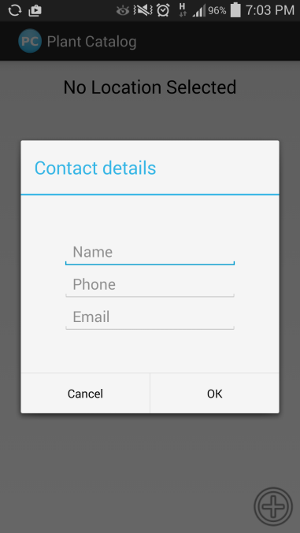

Result: Yes, the prompt comes up for the contact information.

JT5

Test: Does the user have the option to select a natural reserve?

Screen Shot: 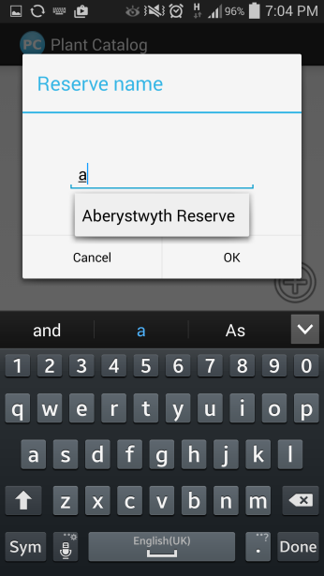

Result: The user can select a reserve such as Aberystwyth or Borth.

JT6

Test: Can the user add a new species name?

Screen Shot: 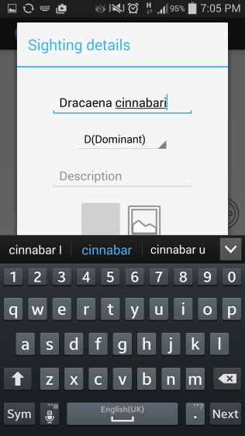

Result: The user can add a new name by tapping on the name option.

JT7

Test: Can the user check gps co-ordinates of the selected site?

Result: The user can check their gps position on the selected site.

JT8

Test: Make sure the data is stored correctly by tapping a radio button?

Screen Shot: 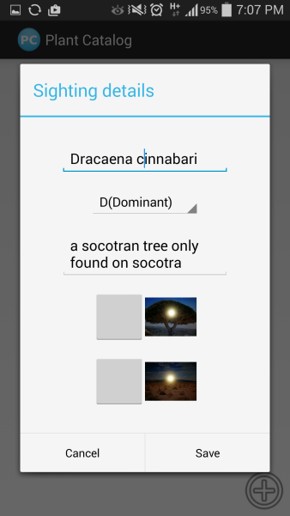

Result: The data can be stored when the button is tapped.

JT9

Test: Can the user add a text comment?

Screen Shot: 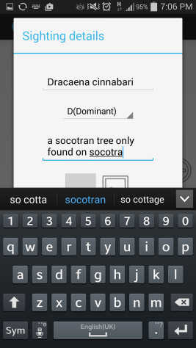

Result: The user can add a text comment by tapping on the comment box?

JT10

Test: Can the user add a photo of the location?

Screen Shot: 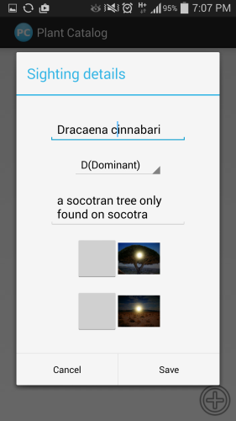

Result: The user can by selecting from gallery when the picture icon is tapped.

JT11

Test: Can the user take a photo of the location?

Screen Shot: 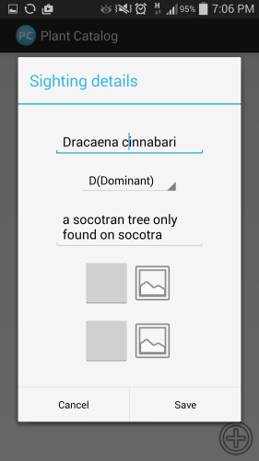 

Result: The user can take a photo by tapping the photo icon.

JT12

Test: Can the user take a photo of the plant species?

Screen Shot: 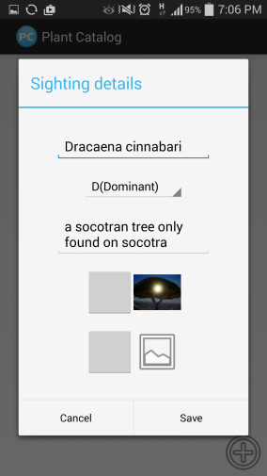

Result: Yes, there is a separate photo icon for the plant species.

JT13

Test: Can the user shoot a new photo for the species?

Screen Shot:  

Result: Yes, the user can shoot a new photo by selecting the photo button besides the plant species tag.

JT14

Test: Can the user delete a species from the recording?

Screen Shot: 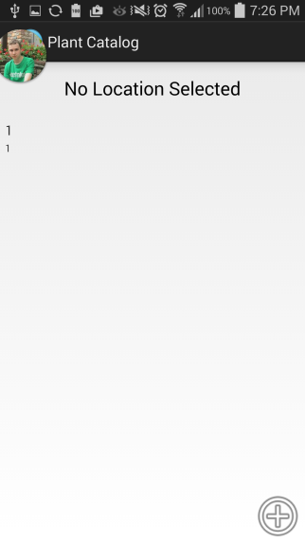 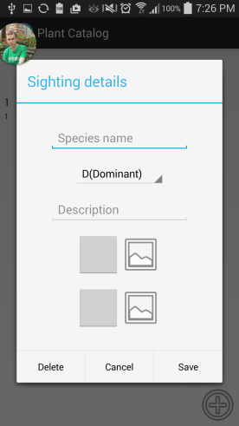 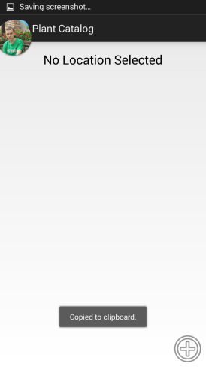

Result: Yes, the user can delete a species from a recording.

JT15

Test: Can the user delete a whole recording?

Screen Shot: 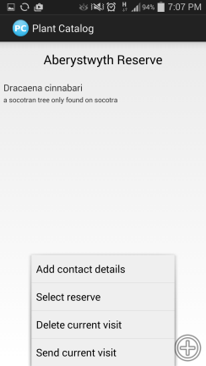 

Result: By tapping an unsent recording and holding it down the option to delete will come up.

JT16

Test: Can the user update a recording that is un-submitted?

Screen Shot: 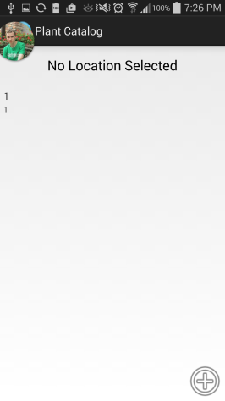 

Result: The user can delete a whole recording if they push the edit button.

JT17

Test: Can the user send a recording to the server?

Screen Shot:  

Result: Click the send recording button to send the data.

JT18

Test: Is the recording sent?

Result: Check the gps and data is sent when the screen goes empty.

The Java test worked and the app functions without a crash.

Suggestions for improvements:

This is what could be improved from the java side and will be formatted as a list.

Java Improvements:

More compatibility

The android app only runs on 4.0 to 4.4.2, this restricts the software to newer phones only and not older phones running android 2,3 and newer versions like 5. The lower versions are still used by a lot of people and they are lost potential customers.

"Success! Record sent"

There is no after prompt stating the record is sent . A simple toast message saying "Success! Record sent" tells the user that the record has been sent to the database and then they can safely move on to another recording session.

GPS always shown

A not so needed feature but a feature that shows the exact gps co-ordinates of the location on the top of the screen if the person has location on. If they want to write it down on paper for later use.

Light Function

A feature useful if the user is working at night and cannot see what they are looking at on the screen. The light provides the ability to see the site and species at night.

Physical Limitations of the program

There are always limiting factors with any project and there were with this project.

Java Portion:

* The program is limited to 4.0 of android as its lowest point of entry. About 15 - 25% of users still use lower versions of android which is a missed demograph for use with the app.
* The program can crash at any time and can interrupt sending if does.
* The location can malfunction on the phone and corrupt the gps data
* The user can potentially fiddle with the data structures if they open the apk and change the code with the correct tools.
* The contact details allow any character to be put in, such as [: as a name and 0000000000 as a number
* The apps speed is dependant on how many apps are open in the background and the phones speed
* The app can freeze if overloaded by something or freeze because of a memory allocation bug